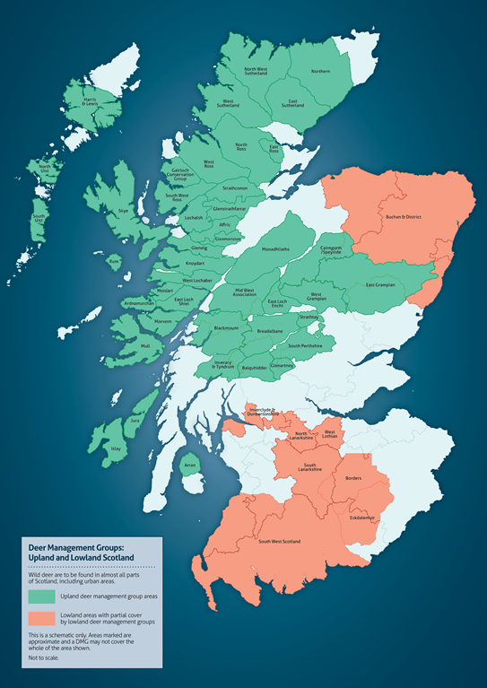
Location of the Lochalsh DMG
Appendix 1: Map showing Deer Management Groups in Scotland
Source of map: ADMG website

